79)Module Information

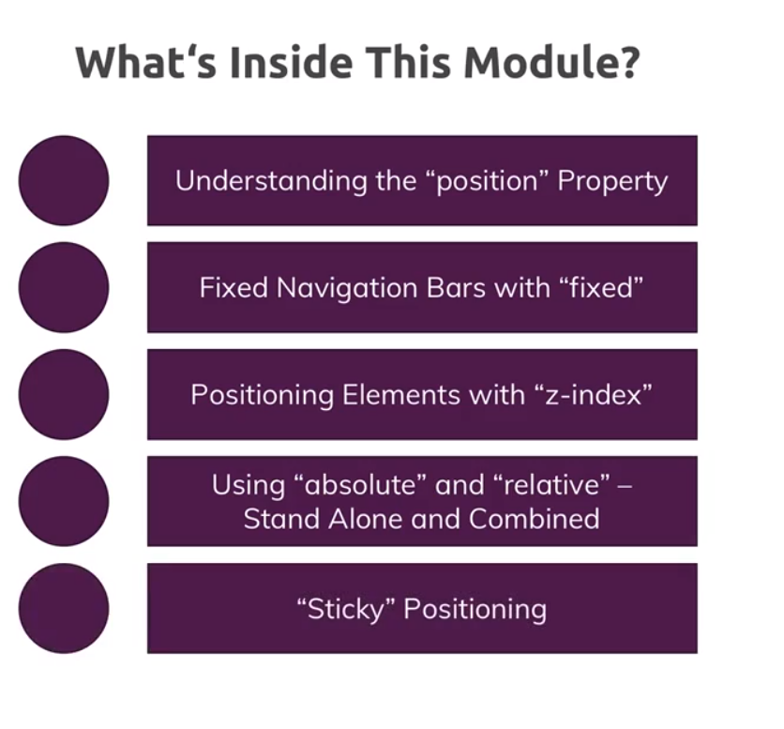

80)why positioning will improve our website

Here it was explained what we want to do, i.e we wan to add make header fixed, we want to add a badge to plus plan.

81)understanding the position – The Theory

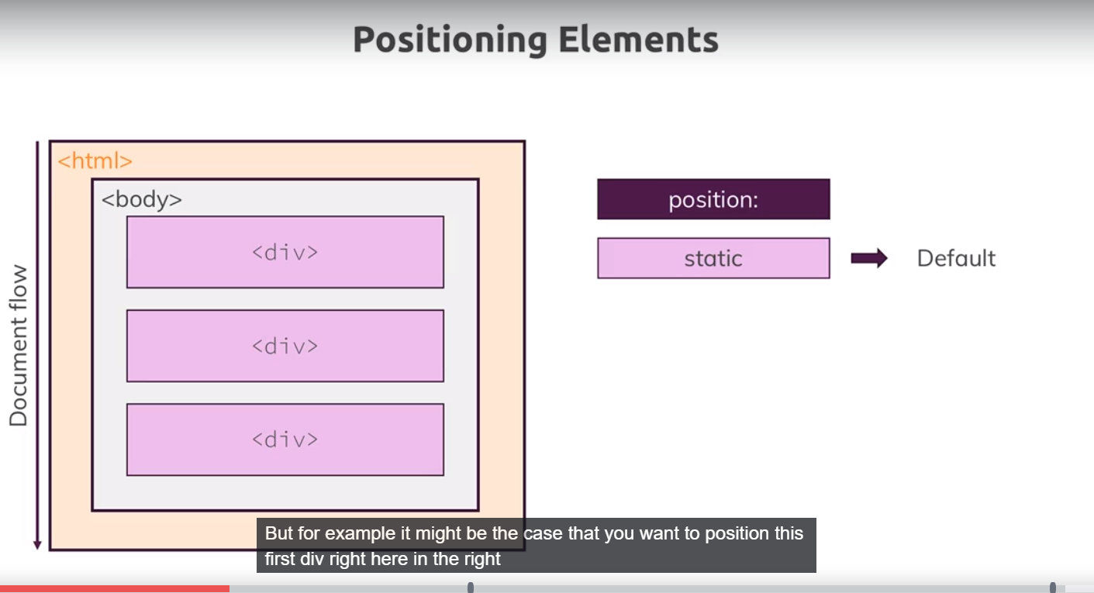

Till now we have not used position property, so thos is what happens we used 3 div. they are block level elements. They are aligned what after another.by default position property has value of static.

Now you might want to position these elements some where else,. Basically you may want to position any element, any where in webpage. this is possible by giving some other value to position property.

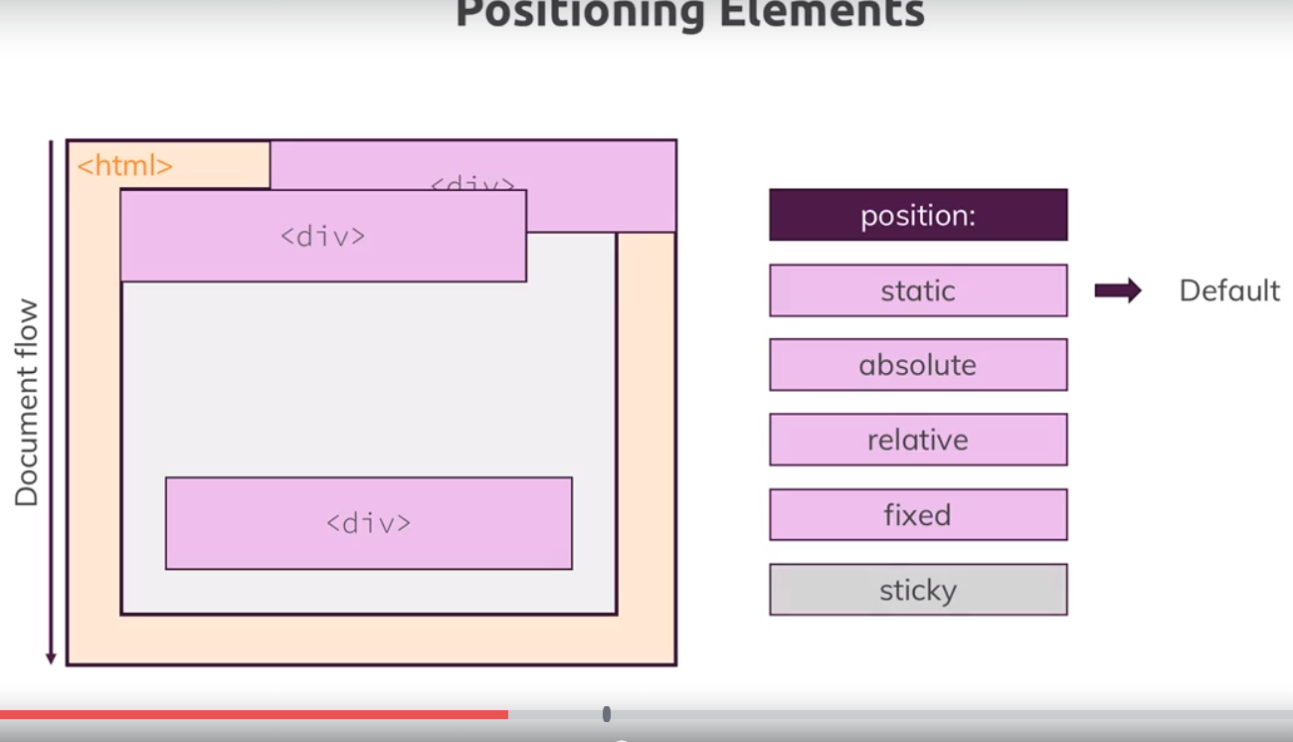

Sticky is new property, so browser support is less. key take away is we w=have to assigned value other than static to position property to change the position of a element.

82)working with fixed property

See lecture

<https://www.udemy.com/css-the-complete-guide-incl-flexbox-grid-sass/learn/v4/questions/6413116>

<https://www.udemy.com/css-the-complete-guide-incl-flexbox-grid-sass/learn/v4/questions/4064908>

here see link shared by manu.

83)

You can skip lecture

Here we applied position: fixed to header. Here we created a problem, like this-

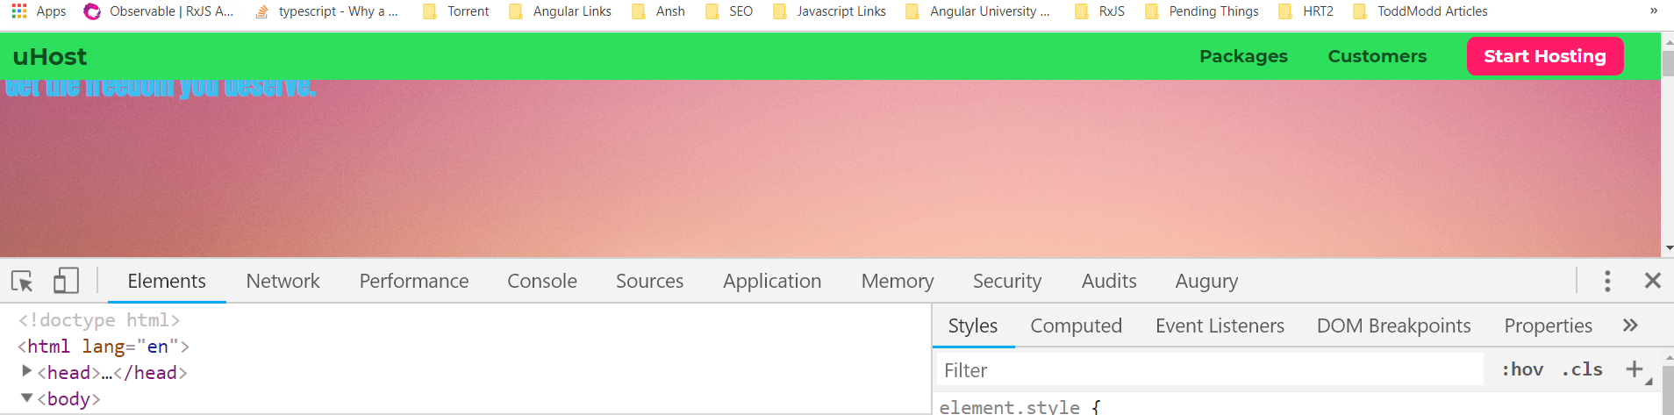

Now we want to have a fixed background in packages section, here it shuld be fixed for whole page.

84)

Here we add a element that contains this background image, max will dive deeper into background images in next section, here I will keep it short becoz focus is on position property.

See questions.

85)

Here we covered z index. See video

86)here we added badge

92) wrap up

